Hybrid Modified GMM & KNN Algorithm
Shahd Bassem S. A. M. Khater, Ahmed S. A. S. El-Mozy, Shereen T. G. E. Abdelfattah

Abstract— The identification of moving objects involves recognizing the motion of entities within a designated region or area. In recent years, considerable attention has been directed towards moving object detection, driven by its diverse applications such as human motion analysis, event detection, video surveillance, robot navigation, anomaly detection, traffic analysis, security, and video conferencing. Video surveillance systems predominantly focus on tracking and classifying moving objects. The typical processing steps in motion detection for video surveillance encompass motion detection, environmental modeling, classification, object detection, understanding behavior, and recognizing activities.
The present research requires the enhancement of the precision of object detection methods relying on Gaussian Mixture Models (GMM) by employing advanced techniques. This improvement is realized through the refinement of pivotal stages in the object detection process. The paper clarifies the methodology of representing individual pixels as a blend of Gaussians and refining the model. Subsequently, the Gaussian distributions of the adaptive mixture model are inspected to recognize those mainly associated with background processes. Each pixel is then classified based on whether the Gaussian distribution that best represents it, is considered part of the background model.

Key Words: Motion detection, Background Subtraction Technique, Object recognition, Video surveillance, Gaussian Mixture Model (GMM), Contour Analysis.

- INTRODUCTION & LITERATURE REVIEW

The increasing need for automated detection systems across personal, commercial, industrial, and military domains has spurred the development of Video Analytics, promising to simplify lives and equip us to stay competitive amidst evolving technologies [1].
However, this trend also necessitates an examination of the challenges inherent in automated video surveillance scenarios. Despite humans' remarkable decision-making abilities, sustaining concentration levels proves challenging, with studies indicating that up to 90% of displayed information is overlooked after just 20 minutes of monitoring [5]. As Closed-Circuit Television (CCTV) systems proliferate, individuals may find themselves tasked with continuously monitoring feeds from numerous cameras around the clock. This underscores the necessity for automatic systems capable of analyzing and archiving video footage from multiple cameras and sensors, seamlessly detecting ongoing events and facilitating data navigation through sophisticated user interfaces—a concept commonly referred to as Video Analytics [3, 7].

Recent advancements in computer vision underscore a heightened focus on developing systems for monitoring and detecting human activity [8]. Such innovations hold significant promise across personal, industrial, commercial, and military spheres, empowering us to stay abreast of emerging technologies and tackle the complexities inherent in automated video surveillance. Video surveillance endeavors to detect, classify, and track objects across image sequences, aiding human operators in understanding and characterizing object behavior. These systems play a critical role in monitoring sensitive areas such as airports, banks, parking lots, and national borders.

The operational framework of automated video surveillance systems encompasses stages such as object detection, classification, and tracking, with motion detection serving as a foundational step. Motion detection aims to segment regions of interest corresponding to moving objects from the background, laying the groundwork for subsequent processes. Various techniques—including frame differencing, adaptive median filtering, and background subtraction—are employed to extract objects from stationary backgrounds, with the latter being the most widely utilized approach. Background subtraction involves crucial steps such as background modeling and foreground detection, wherein statistical descriptions of the background scene are used as reference frames to extract objects from video frames. However, in scenarios featuring quasi-stationary backgrounds, such as swaying trees, flags, or water bodies, accurately detecting moving objects poses challenges. In such instances, traditional single-model background frames may prove insufficient, necessitating the adoption of adaptive background modeling techniques for precise object detection amidst dynamic backgrounds [9, 14].

1.1. Motion-Based Object Detection
Motion-based object detection is a fundamental approach in computer vision and video analysis that focuses on identifying and localizing objects in a scene based on their movement characteristics. This technique leverages the concept that moving objects stand out against a relatively static background, making motion a key indicator for detecting and tracking objects[2].

    - Background Subtraction

The identification of moving individuals within video footage captured by stationary cameras is frequently accomplished through background subtraction techniques. This methodology revolves around isolating moving objects by analyzing the contrast between the current frame and a reference frame known as the "background frame" [4]. The background image serves as a static representation of the scene devoid of any dynamic elements and requires regular updates to accommodate changes in lighting and spatial configurations. Advanced models have expanded the scope of "background subtraction" beyond its literal interpretation.

Background subtraction is the prevailing technique for motion detection, leveraging disparities between the present image and a stored background image to pinpoint areas of motion and provide pertinent object-related data [6]. The efficacy of this method hinges upon the accurate initialization and continuous updating of the background image, both of which profoundly influence the precision of test outcomes. Consequently, this study employs a robust approach to initialize and dynamically update the background image.
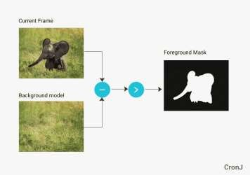
Fig. (1). Foreground mask generated after background subtraction.

    - Frame Differencing
Frame differencing involves determining the presence of moving objects by computing the disparity between two consecutive images[10]. Its computational simplicity and ease of implementation make it suitable for a wide range of dynamic environments. However, it often fails to provide comprehensive information about moving objects, leading to phenomena such as empty frames and consequently reducing the accuracy of object detection.

    - Optical Flow
Optical flow refers to the visual pattern of object motion in a scene resulting from the relative movement between the scene and a camera (or observer). The optical flow method is employed in various applications such as enhancing video compression, segmenting images for object tracking, and estimating motion vectors for moving objects [11]. In motion detection using optical flow, the approach involves calculating the optical flow field within an image or video frame. This field represents the displacement of pixels over time, allowing the detection of moving objects based on the flow vectors.
Despite its effectiveness, optical flow methods are typically computationally intensive and time-consuming. Optical flow techniques are capable of stabilizing the background plane by modeling background motion, making it feasible to detect motion even in scenarios involving a moving camera and dynamic background. However, many optical flow methods require significant computational resources and are not suitable for real-time applications without specialized hardware[12].

- BASIC BACKGROUND SUBTRACTION ALGORITHM
A fundamental stage in the background subtraction (BS) process involves background modeling, a crucial step wherein a fixed image is chosen to serve as the backdrop, excluding all moving elements.

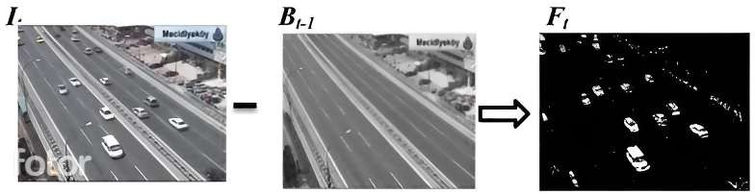

Fig. 2a. Foreground Mask (Ft) generated after background subtraction, It is input video frame at a time t. Bt-1 is the background model estimated at instance of timet-1.
The absolute difference (Dt) between the current frame (It) and the static image is computed for every frame in the video sequence. This static image, often referred to as the reference background or background model, is denoted as Bt-1. Consequently, the disparity image (Dt) is obtained through the following equation:
Dt = |It — Bt—1| (1)
A foreground mask (Ft) is generated through the application of a threshold to a difference image.
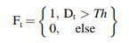
(2)

Illustrated in Fig. (2a) is an instance of the background subtraction procedure. To accommodate alterations within the scene over time, ensuring adaptability of the background model is imperative. The algorithm governing this learning phase necessitates a gradual and online execution. Employing a straightforward recursive technique, all pixels are updated utilizing an Infinite Impulse Response (IIR) filter.
Bt = (1 — α)Bt—1 + αIt (3)
where α is learning rate which is a constant in the range [0, 1]. Bt—1 and It are back ground and current image at time t-1 and t, respectively. ( It ^{B}t-1 ^{F}t)

- BACK-GROUND MODELING USING K-MEANS
Background modeling using k-means clustering is a technique employed in computer vision to separate foreground objects from the background in video sequences. The process involves representing each pixel as a data point and applying k-means clustering to group similar pixels into clusters[15]. The cluster representing the most frequently occurring pixel values across frames is considered as the background model. This model is then used to identify and extract foreground objects by subtracting the background from each frame. K-means clustering offers a straightforward and computationally efficient approach to segmenting pixels based on their characteristics, making it suitable for real-time applications such as surveillance, motion detection, and video analytics[16]. However, challenges such as handling dynamic backgrounds and selecting appropriate parameters for clustering require careful consideration to ensure accurate and robust background modeling.

- BACK-GROUND MODELING USING GMM
Gaussian Mixture Models (GMMs) are employed for background modeling in video sequences by representing pixel intensities as a blend of Gaussian distributions, with each distribution representing a potential background appearance. Throughout the modeling process, GMMs dynamically learn and update the statistical properties of the background by adjusting the parameters (mean and covariance) of the Gaussian components over time[24]. This adaptive learning allows the model to adapt to gradual changes in the background scene. When processing a new frame, pixels that substantially diverge from the learned background model in terms of intensity distribution are classified as foreground, indicating the presence of moving objects or anomalies. GMM-based background modeling is effective for detecting and segmenting moving objects in video surveillance and related applications [27], leveraging the probabilistic nature of GMMs to capture complex background variations and foreground dynamics [17].

  - Building the Mathematical Model of the GMM

In the mathematical framework of Gaussian Mixture Models (GMM), several key components are defined to facilitate the understanding and estimation of complex data distributions.

    - The Probability Density Function (PDF) of a Gaussian distribution

Serves as a fundamental building block. It encapsulates the likelihood of observing a specific data point within the distribution. Parameters such as the mean (μ) and variance (σ^2) characterize this PDF, influencing the shape and spread of the distribution. To get the PDF of the GMM we will start with the exponential function and try to manipulate and modify it until we get the multivariate Gaussian component which is the building block of the GMM. Where increases rapidly on the positive side, while decreases rapidly on the negative side. The squared input value results in two characteristics: it imparts symmetry to the function and accelerates the growth of the function's output even more rapidly. On the other hand, the reversed squared input value where we get the familiar bell-shaped curve, however, this does not conform to the normal distribution, and several additional elements must be incorporated to achieve it which are:
      - Mean (we want to change the center) we can do this by shifting the x-axis by a value equal to the mean we want .
      - Variance (we want to control the width) we can do this by controlling the strength of the input value by multiplying it with a constant known as standard deviation or sigma

    - Mixture model
A Gaussian Mixture Model (GMM) represents the background scene as a composite of multiple Gaussian distributions, where each distribution, or component, is defined by its mean vector and covariance matrix. These components are weighted by mixing coefficients that determine their relative contributions to the overall background model [23]. The GMM is a probabilistic model that captures the underlying variability and complexity of the background by blending different Gaussian patterns. This mixture modeling approach is commonly used in tasks like background subtraction and anomaly detection in computer vision and image processing applications [25], providing a versatile framework for modeling and understanding diverse background scenes based on observed data distributions.

  - Initializing the Parameters
The initialization of parameters for Gaussian Mixture Model (GMM) based background modeling involves several key decisions. First, the number of Gaussian components (K) needs to be determined, reflecting the complexity of the background scene. This value is typically selected based on empirical analysis of the scene's variability and the desired granularity of the model. Secondly, the learning rate (α) dictates the speed of adaptation to changes in the scene; a smaller α results in slower updates, allowing for more stable background modeling, whereas a larger α facilitates quicker adaptation to dynamic scenes. The threshold (τ) is crucial for pixel classification, where pixels are categorized as background or foreground based on their likelihoods under the learned background model; choosing an appropriate threshold is vital for accurate foreground detection. Lastly, selecting the covariance type (e.g., diagonal or full covariance matrices) for each Gaussian component impacts the flexibility and complexity of the model in capturing the background's statistical characteristics [26]. These initialization choices play a critical role in the effectiveness and performance of GMM-based background modeling algorithms, influencing how well the model adapts to scene variations and distinguishes moving foreground objects from the static background [18,19,20].

  - Modeling Pixels
    - Initialization:
Initialize the Gaussian mixture parameters (mean, covariance, and weight) for each component.
    - Estimation
Update the parameters iteratively as new observations are made. This involves updating the mean, covariance, and weight of each component based on the current pixel value and the learning rate.

    - Likelihood Calculation:
the goal is to compute the probability of the observed pixel value given the Gaussian components of the model. Each pixel in the current frame is evaluated against each Gaussian component (distribution) to determine how likely it is that the pixel belongs to each distribution.
for a pixel value 𝑥 , and a Gaussian component 𝑗 with mean μ𝑗, covariance matrix 𝛴_{𝑗} , and weight 𝜔_{𝑗} , the likelihood
P(x | j) is given by the Gaussian probability density function (PDF):

where 𝑑 d is the dimensionality of the feature vector (typically, 𝑑 = 1 d=1 for grayscale pixel values and 𝑑 = 3 d=3 for RGB color values)[30].
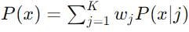
The overall likelihood of the pixel value under the mixture model is the weighted sum of the likelihoods for each Gaussian component:
where 𝐾 K is the number of Gaussian components.

    - Background Modeling
Classify the pixel as background if its likelihood under the background model exceeds a predefined threshold. Otherwise, consider it as part of the foreground.

4.3.4.1 History
The history parameter determines the number of past frames (history) that are used to initialize this background model.

      - Initialization and Accumulation of History:
        - If the history buffer is not yet full, new frames are added to it.
        - If the history buffer is full, the oldest frame is removed, and the new frame is added.
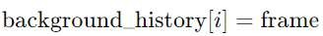
      - Background Model Update:
        - Start with the first frame in the history as the initial background model.
        - Update the background model by blending each historical frame with the current background model using the learning rate 𝛼 .
- PROPOSED SYSTEM (MODIFIED GMM& KNN-BASED BACKGROUND SUBTRACTION)
This section illustrates the foundation, development of the GMM model, its initialization and maintenance, foreground, and detection.

  - Foundation
In the realm of traffic surveillance systems, Friedman and Russell (citations [1,7]) introduced a method to characterize background pixels by employing a blend of three Gaussian distributions representing distinct elements: the road, vehicles, and shadows. They initialized this model using an Expectation-Maximization (EM) technique [6]. Subsequently, they manually assigned labels to these Gaussians based on a heuristic approach: the darkest Gaussian component was designated as representing shadows, while the remaining two components were identified as representing the road and vehicles, respectively, with the vehicle component determined by the largest variance. This configuration remained constant throughout the system's operation. Each pixel underwent comparison with these Gaussians to determine foreground detection, with classification based on the closest matching Gaussian.
Maintenance of this model was achieved through the utilization of an incremental EM technique to enable real-time adaptation [1,7]. Stauffer and Grimson (citation [1]) further developed this concept by incorporating recent color property variations of each pixel into their Gaussian model.

  - Pixel processes and parameters initialization

For: {x1, ,xi}={I(x0,y0,i):1<=i<=t}, at any time t, we have a history of a particular pixel (X0, Y0). Models the values of particular pixels
as a mixture of Gaussians. At any time, t, we have k distributions of Gaussians for each pixel (used 3 Gaussians). For each Gaussian, we have:

    - 𝜔𝑖,𝑡 : is an estimate of the weight of ith Gaussian in the mixture, at time t. initialized with uniform distribution which lead to:
      - Equal Starting Point
By initializing the weights uniformly, each Gaussian component starts with an equal probability of representing the pixel's value. This prevents any initial bias towards specific components and ensures that all components are considered equally likely to begin with. Over time, the weights will adapt based on the observed pixel values, allowing the model to accurately represent the pixel distribution.

      - Stability in Early Iterations
Uniform initialization provides stability in the early stages of the algorithm. Since no prior information is available about which Gaussian might be more relevant, giving each component an equal weight helps in avoiding any premature convergence to incorrect components. This can help in reducing the initial noise and variability in the background model.

      - Simplified Implementation
Using a uniform distribution simplifies the implementation and initialization process. It avoids the need for complex calculations or heuristics to determine initial weights, making the algorithm easier to implement and understand.

      - Fair Competition Among Components
When the weights are initialized uniformly, each Gaussian component has an equal chance of representing the observed pixel values. This fair competition ensures that the most appropriate Gaussian components will emerge over time as they compete based on their fit to the data. The components that best match the observed values will naturally receive higher weights, leading to a more accurate and robust background model.

      - Improved Convergence
Uniform initialization can lead to improved convergence properties. Since all components start with equal importance, the algorithm is less likely to get stuck in local minima where certain components dominate prematurely. This helps in achieving a more accurate and stable background model as the algorithm progresses.

    - 𝜇_{𝑖,𝑡}: is the mean value of ith Gaussian in the mixture, at time t, initialized with vector of zeros which lead to:
      - Initializing with zeros allows the model to start with a simple assumption and quickly adapt to the actual data as it processes more frames.

      - Handling Unknown Initial Conditions: When there is little to no prior knowledge about the data distribution, initializing with zeros is a reasonable choice. It allows the algorithm to explore the data and converge to the appropriate means based on the observed data rather than being influenced by potentially incorrect initial guesses.

    - Σ_{𝑖,𝑡}: covariance matrix of ith Gaussian in the mixture, at time t :
Identity Matrix : is to initialize the covariance matrix as an identity matrix multiplied by a small constant. This ensures that the initial covariance is equal in all directions and prevents singularities. A singular covariance matrix leads to degenerate Gaussian distributions, affecting the model's ability to represent data distributions accurately. By initializing covariance matrices with non-zero values, such as small positive values or an identity matrix, we can prevent singularities from occurring. This initialization ensures that the matrix remains invertible and avoids numerical issues during computations.

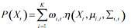
For computational reasons, we assumed that the RGB color components are independent and have the same variances. So, the covariance matrix is of the form: 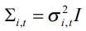 (1)
Now, the probability of observing the current pixel value is: (2)

Where ‘K’ is the number of Gaussian distribution, ω,µ,∑ as stated previously, and (3) is the gaussian probability density function.
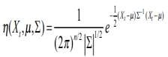
(3)

So, each pixel is characterized by a mixture of K Gaussians. Once the background model is defined, the different parameters of the mixture of Gaussians must be initialized. The parameters of the MOG’s model are the number of Gaussians K, the weight
𝜔𝑖,𝑡,t associated to the 𝑖^{𝑡ℎ} Gaussian at time t, the mean 𝜇𝑖,𝑡 and the covariance matrix Σ𝑖,𝑡.

  - Background model estimation:
the Gaussians are ordered by the value of ω/σ Then, the first B distributions are chosen as the background model[28], where

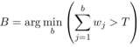
(12)

T is a measure of the minimum portion of the data that should be accounted for by the background[29].
  - Update the mixture model:
Every new pixel value, Xt, is checked against the existing K Gaussian distributions until a match is found. A pixel matches a Gaussian distribution if the Mahala Nobis distance.
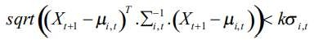 (4)
Where K is a constant threshold equal to 2.5, now two cases can occur:

Case 1: A match is found with one of the K Gaussians. In this case, if the Gaussian distribution is identified as a background one, the pixel is classified as background else the pixel is classified as foreground. For the matched component, the update is done as follows:
ωi,t +1 =1−α ωi,t +α (5) where α is a constant learning rate.
μ_{i,t+1} =(1−ρ)μ_{i,t} +ρ.X_{t+1} (6)
σi ,t +1 =(1−ρ)σi,t +ρ(Xt+1 −μi,t +1).(Xt +1 −μi,t+1 ) (7) where ρ =α.η Xt+1, μi ,∑i
For the unmatched components, μ and ∑ are unchanged, only the weight is replaced by ω_{j,t+1} = (1−α)ω_{j,t} (8)
Case 2: No match is found with any of the K Gaussians. In this case, the pixel is classified as foreground & the least probable distribution k is replaced with a new one with parameters:
□_{k,t+1}=Low Prior Weight (9)
μk,t+1 =Xt +1 (10)
□² =Large Initial Variance (11)
Once the parameters maintenance is made, foreground detection can be made, and so on. Complete studies on the signification and the setting of the parameters can be found in [22, 23].

    - Learning rate:
The alpha parameter in the algorithm has a significant effect on its performance, particularly in terms of how quickly the background model adapts to changes in the scene. Here’s how it works:
- Low Alpha: When alpha is low, the background model changes slowly over time. This means that the algorithm is more resistant to short-term fluctuations or noise in the video frames. However, it may take longer for the background model to adapt to significant changes in the scene, such as sudden lighting changes or moving objects.
- High Alpha: Conversely, when alpha is high, the background model adapts quickly to changes in the scene. This can help the algorithm respond rapidly to changes like moving objects or changes in lighting conditions. However, it may also make the algorithm more sensitive to noise, leading to false detections or instability in the background model.

  - KNN-Model

The KNN model is implemented through two main steps:

Background Decision: This step involves classifying each pixel as either background or foreground by comparing it to its historical pixels, History Update: This step updates all historical pixels at varying rates[31].

Background Decision

For each pixel, historical values from previous frames are stored in three different history lists: short, medium, and long. Each history list contains a predefined number of samples, such as N=7, where each sample is represented by a structure storing the red, green, and blue channel values (Ri, Gi, and Bi) for the i-th sample pixel, xi. Additionally, a flag (Flagi) is used to indicate if xi is a potential background pixel (Flagi = 1) or a foreground pixel (Flagi = 0). A potential background pixel is either classified as background or likely to be classified as such.

When a new pixel, xt, is obtained from the next frame, the algorithm computes the Euclidean distance Dis(t,i) in RGB color space between xt and each historical sample xi (i = 1, ..., 3N) in the three history lists:

As the algorithm iterates through all 3N historical samples, a counter (CountD) tracks the number of distances smaller than a threshold
𝑇ℎ 𝐷. Simultaneously, another counter (CountF) counts the number of samples with Flag=1where Dis(t,i)< 𝑇ℎ 𝐷.The values of CountD and CountF are then compared to a threshold 𝑇𝑐 𝑘 to classify xt as either background or foreground.[31] The pixel xt is immediately classified as background (value = 1) if there are more than 𝑇𝑐 𝑘 potential background pixels within the distance threshold 𝑇ℎ𝐷 Otherwise, xt is classified as foreground (value = 0). If CountD exceeds 𝑇𝑐 𝑘, xt can be reclassified as potential background, setting its Flag value to 1. Each frame is processed in this way, resulting in a binary mask image where background pixels are labeled as 1 and moving targets as 0.

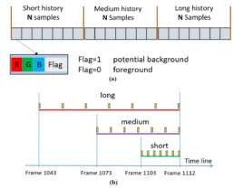
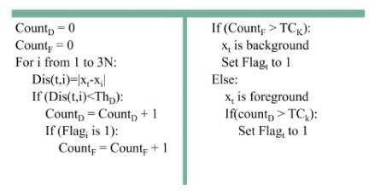
FIGURE 5. The structure of the histories for a pixel in KNN background FIGURE 6. Pseudo code for classifying a pixel xt as background or subtraction model. (a) Each of the three histories contains N samples foreground. xi is the i-th pixel in the history, and 𝑇ℎ𝐷 and 𝑇𝑐𝑘 are composed of R, G, B, and a Flag value. (b) The three histories contain predefined thresholds.
the same number of samples but cover different time ranges.

History Update

The three history lists cover different time ranges, as shown in Figure 5. For instance, the short history covers frames from 1103 to 1112, the medium history from 1073 to 1112, and the long history from 1043 to 1112.

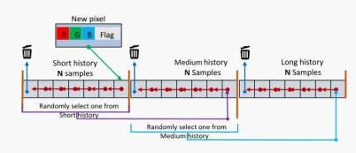
FIGURE 7. History update.

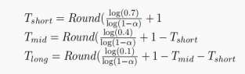
This indicates that the short history contains only the most recent samples, while the medium and long histories include samples from earlier frames with larger intervals between samples. Hence, the three histories are updated at different rates according to the following equations from OpenCV:

Here, Round(.) is the rounding function, and α (0 < α < 1.0) is the learning rate, set to 0.02 in this study. Once the time ranges are determined, the update ratio Rj is calculated as: Rj=Round(𝑇𝑗)+1
𝑁

Where 𝑇𝑗 represents 𝑇𝑠ℎ𝑜𝑟𝑡 , 𝑇𝑚𝑖𝑑 and 𝑇𝑙𝑜𝑛𝑔 , and NNN is the number of samples in each history (e.g., N=7 in Figure 5). Consequently, the short history is updated most frequently, while the long history is updated the least[31].
Figure 7 details the updating process for the three histories. Samples in each history are managed by a queue, with the head on the left and the rear on the right. When a new pixel arrives, it is first classified as potential foreground (Flag = 1) or background (Flag = 0), then added to the rear of the short history. Since the short history only retains N samples, the oldest sample on the left is removed from the queue. For updating the medium history, a random sample from the short history is appended to the medium history's rear, and the oldest sample is removed from the medium history. Similarly, the long history is updated by selecting a random pixel from the medium history. This process ensures that the samples are chronologically sorted, and the earliest one is discarded after updating the short history. When the algorithm iterates from the first frame to the last, the three histories are updated at different rates.

By combining K-Nearest Neighbors (KNN) and Gaussian Mixture Model (GMM), a motion detection system can effectively utilize the strengths of both non-parametric and parametric approaches. KNN’s adaptability and flexibility enable it to rapidly respond to changes in the environment, capturing complex and dynamic patterns in the background. This is particularly useful in situations where the background is constantly changing or contains frequent movements. GMM, on the other hand, provides a structured and detailed background model by representing the background as a mixture of Gaussian distributions. This parametric approach excels in distinguishing between foreground and background elements, even in the presence of subtle changes such as lighting variations and shadows. By integrating these two methods, the hybrid system achieves a balance between responsiveness and stability, significantly enhancing the accuracy, efficiency, and robustness of motion detection. This makes the system highly effective across a wide range of environments and conditions, such as in surveillance systems where it can accurately detect intruders in both stable and dynamic settings, in traffic monitoring where it can reliably identify moving vehicles and pedestrians, and in wildlife monitoring where it can track animals in rapidly changing natural habitats. The hybrid approach not only reduces false positives and negatives but also ensures real-time performance, making it a versatile and powerful solution for various motion detection applications.

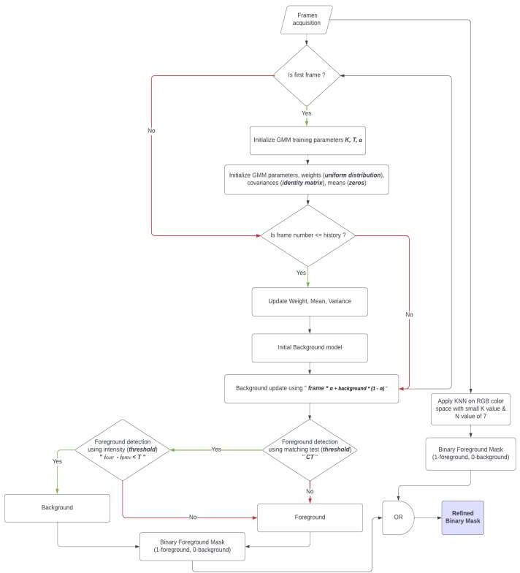

Fig. (2). Flow chart for hybrid-modified GMM-KNN based object detection.

- TESTING & EVALUATION OF GMM & MODIFIED GMM

  - Experimental setup
The current research is centered on the optimization of GMM training parameters, specifically K, α, and T. For the experiment, a high fixed value for K was selected. Different combinations of α and T were evaluated across the dataset to determine the most effective pair for object detection across multiple videos. The Total Error (TE), a key performance metric, was introduced to identify the pair of α and T with the lowest TE value, which represents the total misclassifications across all videos. The object detection system underwent testing with various α and T parameters across a range of background-covering sequences, with emphasis on sequences from the four datasets we used.

  - Training and testing
The dataset provider has outlined comprehensive recommendations for both training and testing procedures. Below are concise descriptions of sequences, accompanied by instructions for training and testing.

- Normal Case (NC)- A girl with brown hair and wearing white & black clothes walks confidently across a green screen studio. She smiles and makes eye contact with the viewer, as if she is addressing them directly.

- Shadow Case (SC) - The frame shows a girl in a long,flowing, floral clothes and a headscarf walking down a sidewalk. In the background is a large building with many windows. The girl’s shadow appears throughout the video while she’s walking.

- Night Case (NIC) - It shows a man walking down a foggy street at night. The street is lit by lampposts that cast pools of light on the sidewalk. The man is in the center of the frame, and he is the only person visible. He is wearing a long coat.

- Bad Weather Case (BWC) - The video frame shows a man walking down a sidewalk on a snowy street at night. The time of day appears to be late at night, as the streetlights are on, and the sky is dark. The man is bundled up in a winter coat and hat, and he appears to be trudging through the snow, which suggests the weather conditions are bad.

  - Results of GMM & Modified GMM

In this section, we present the results of our motion detection project using the background subtraction technique. The performance of the Gaussian Mixture Model (GMM) and our Modified GMM is evaluated through a series of metrics. Table 1 displays the core performance metrics for the GMM, specifically true positives (TP), true negatives (TN), false positives (FP), and false negatives (FN). These metrics provide a foundational understanding of the model’s ability to correctly identify motion versus background. In Table 2, we further analyze the GMM performance through derived key metrics: accuracy, precision, recall, and F1 score, which offer a more holistic view of the model’s effectiveness in various aspects. Tables 3 and 4 mirror the structure of Tables 1 and 2, respectively, but for the Modified GMM. This comparison allows us to evaluate the improvements brought by our modifications, demonstrating the enhanced performance in motion detection through a detailed examination of both basic and derived metrics.

Performance parameter evaluation of GMM , KNN & Hybrid Modified GMM & KNN

Table 1

Dataset | True Positive
Dataset | Basic GMM | KNN | Modified GMM & KNN
Normal Case (NC) | 60441 | 34648 | 58947
Shadow Case (SC) | 66329 | 17914 | 54095
Night Case (NIC) | 11226 | 1666 | 10222
Bad Weather Case (BWC) | 78486 | 12625 | 85013
Overall | 216,482 | 66,853 | 208,277
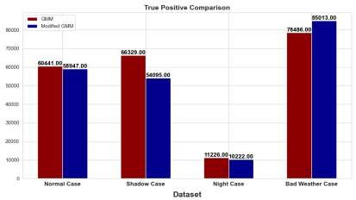
Fig. 6a. True positive of GMM compared to Modified GMM & KNN based object detection.
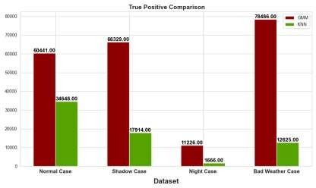
Fig. 6b. True positive of GMM compared to KNN based object detection.

Table 2

Dataset | True Negative
Dataset | Basic GMM | KNN | Modified GMM & KNN
Normal Case (NC) | 1285445 | 1308352 | 1303511
Shadow Case (SC) | 1129506 | 1172068 | 1126806
Night Case (NIC) | 1351358 | 1367680 | 1362786
Bad Weather Case  (BWC) | 1269753 | 1274108 | 1269484
Overall | 5,036,062 | 5,122,208 | 5,062,587
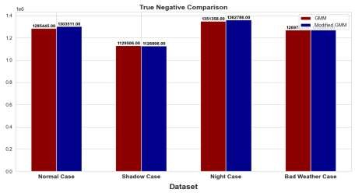
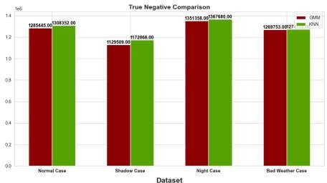
Fig. 6c. True Negative of GMM compared to Modified GMM & KNN based object detection.
Fig. 6d. True Negative of GMM compared to KNN based object detection

Table 3

Dataset | False Positive
Dataset | Basic GMM | KNN | Modified GMM & KNN
Normal Case (NC) | 23104 | 197 | 5038
Shadow Case (SC) | 53688 | 11126 | 56388
Night Case (NIC) | 16856 | 534 | 5428
Bad Weather Case (BWC) | 8991 | 4636 | 9260
Overall | 102,639 | 16,493 | 76,114
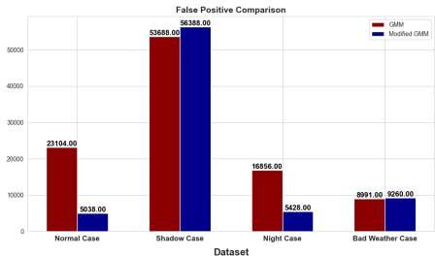

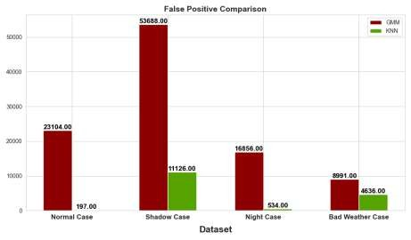
Fig. 6e. False Positive of GMM compared to Modified GMM & KNN based object detection.
Fig. 6f. False Positive of GMM compared to KNN based object detection.

Table 4

Dataset | False Negative
Dataset | Basic GMM | KNN | Modified GMM & KNN
Normal Case (NC) | 13410 | 39203 | 14904
Shadow Case (SC) | 132877 | 181292 | 145111
Night Case (NIC) | 2960 | 12520 | 3964
Bad Weather Case (BWC) | 25170 | 91031 | 18643
Overall | 174,417 | 324046 | 182,622
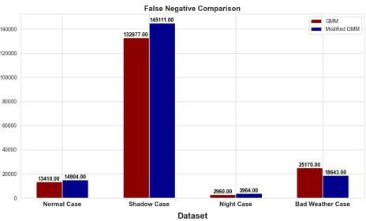
Fig. 6g. False Negative of GMM compared to Modified GMM & KNN based object detection.
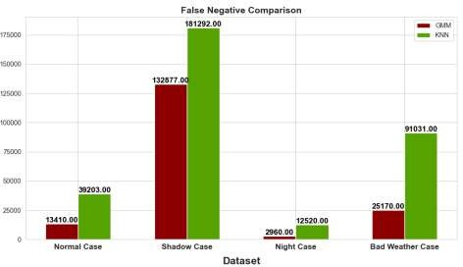
Fig. 6h. False Negative of GMM compared to KNN based object detection.

Table 5

Dataset | Accuracy
Dataset | Basic GMM | KNN | Modified GMM & KNN
Normal Case (NC) | 0.973 | 0.97 | 0.985
Shadow Case (SC) | 0.865 | 0.86 | 0.854
Night Case (NIC) | 0.98 | 0.99 | 0.99
Bad Weather Case (BWC) | 0.975 | 0.93 | 0.979
Overall | 94.82% | 93.75% | 95.2%

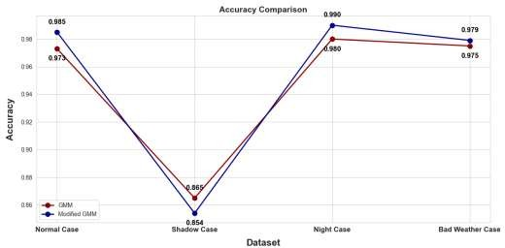
Fig. 6i. False Negative of GMM compared to Modified GMM & KNN based object detection.
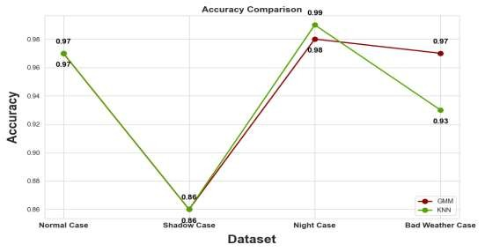
Fig. 6j. Accuracy of GMM compared to KNN based object detection.

Table 6

Dataset | Precision
Dataset | Basic GMM | KNN | Modified GMM & KNN
Normal Case (NC) | 0.723 | 0.99 | 0.921
Shadow Case (SC) | 0.552 | 0.65 | 0.489
Night Case (NIC) | 0.399 | 0.75 | 0.653
Bad Weather Case (BWC) | 0.897 | 0.73 | 0.901
Overall | 64.2% | 78% | 74.1%

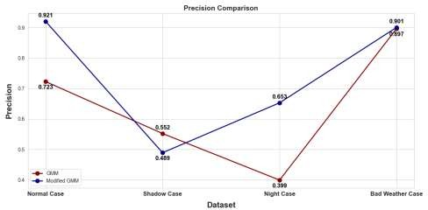
Fig. 6k. Precision of GMM compared to Modified GMM & KNN based object detection.
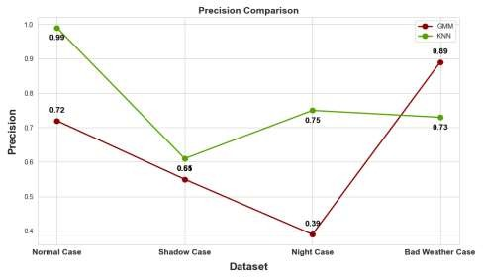

Fig. 6l. Precision of GMM compared to KNN based object detection.

Table 7

Dataset | Recall
Dataset | Basic GMM | KNN | Modified GMM & KNN
Normal Case (NC) | 0.818 | 0.46 | 0.798
Shadow Case (SC) | 0.332 | 0.08 | 0.271
Night Case (NIC) | 0.791 | 0.11 | 0.720
Bad Weather Case (BWC) | 0.757 | 0.12 | 0.820
Overall | 67.4% | 19.25% | 65.2%
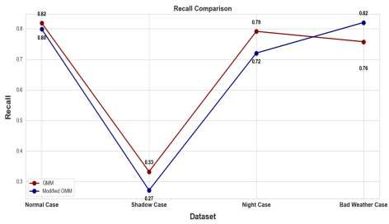
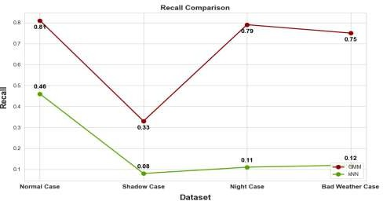
Fig. 6m. Precision of GMM compared to Modified GMM & KNN based object detection.
Fig. 6n. Precision of GMM compared to KNN based object detection.

Table 8

Dataset | F1 Score
Dataset | Basic GMM | KNN | Modified GMM & KNN
Normal Case (NC) | 0.768 | 0.46 | 0.855
Shadow Case (SC) | 0.415 | 0.08 | 0.349
Night Case (NIC) | 0.531 | 0.11 | 0.685
Bad Weather Case (BWC) | 0.821 | 0.12 | 0.859
Overall | 63.37% | 19.25% | 68.7%
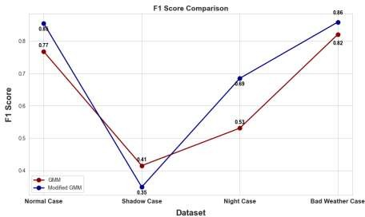
Fig. 6o. Precision of GMM compared to Modified GMM & KNN based object detection.
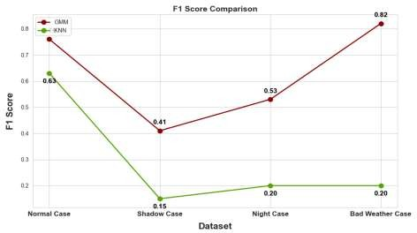
Fig. 6p. Precision of GMM compared to KNN based object detection.

REFERENCES
- Moving object detection using modified GMM based background subtraction - ScienceDirect
- Yi ğ ithan Dedeo ğ lu,” MOVING OBJECT DETECTION,TRACKING AND CLASSIFICATION FORSMART VIDEO SURVEILLANCE”, August, 2004.
- Paul Viola, Michael Jones, “Detecting Pedestrians using patterns of motion and appearance”, International journal of Computer Vision 63(2), 153-161, 2005.
- Neeti A. Ogale, “A Survey of Techniques for Human Detection from Video,”, unpublished.
- [1302.1539] Image Segmentation in Video Sequences: A Probabilistic Approach (arxiv.org)
- Prithviraj Banerjee and Somnath Sengupta, “Human Motion Detection and Tracking for video Surveillance,”, unpublished
- X. Niu, Y. Zhu, Q. Cao, X. Zhang, W. Xie, K. Zheng, An online-traffic-prediction based route finding mechanism for smart city, Int. J. Distributed Sens. Netw. 11 (8) (2015), 970256.
- Bo Wu and Ram Nevatia, “Detection and tracking of multiple partially occluded Humans by Baysian combination of edgelet based part detector” ,International Journal of Computer Vision 75(2), 247-266, 2007
- Yang Ran, Issac Weiss, “Pedestrian Detecting via periodic motion analysis”, International Journal of Computer Vision 71(2), 143-160, 2007.
- Abhishek Kumar Chauhan, Prashant Krishan, Moving object tracking using Gaussian mixture model and optical flow, Int. J. Adv. Res. Comput. Sci. Software Eng. (April 2013).
- Milin P Patel and Shankar K. Parmar, “Moving Object Detection with Moving Background using Optic Flow,” IEEE Conference on Recent Advances and Innovations in Engineering, Jaipur, pp 1-6, 2014.
- Vaibhavi S Bharwad et al,” Motion Detection for Intelligent Video Surveillance System: A Survey”, 2015
- D. Reynolds, Gaussian mixture models, in: S.Z. Li, A.K. Jain (Eds.), Encyclopedia of Biometrics, Springer, Boston, MA, 2015, https://doi.org/10.1007/978-1- 4899- 7488-4_196.
- Stauffer and W. E. L. Grimson., “Adaptive background mixture models for real time tracking”, International conference on Computer Vision and Pattern Recognition, 2,1999.
- Butler, Darren E and Bove, V Michael and Sridharan, Sridha. Real-Time Adaptive Foreground/Background Segmentation. EURASIP Journal on Advances in Signal Processing 2005.
- Butler, Darren E and Bove, V Michael and Sridharan, Sridha. Real-Time Adaptive Foreground/Background Segmentation. EURASIP Journal on Advances in Signal Processing 2005.
- Ha SV-U, Chung NM, Phan HN, Nguyen CT. TensorMoG: A Tensor-Driven Gaussian Mixture Model with Dynamic Scene Adaptation for Background Modelling. Sensors. 2020; 20(23):6973.
- Popović B, Cepova L, Cep R, Janev M, Krstanović L. Measure of Similarity between GMMs by Embedding of the Parameter Space That Preserves KL Divergence. Mathematics. 2021; 9(9):957.
- Lee, Hj., Cho, S. (2004). Combining Gaussian Mixture Models. In: Yang, Z.R., Yin, H., Everson, R.M. (eds) Intelligent Data Engineering and Automated Learning – IDEAL 2004. IDEAL 2004. Lecture Notes in Computer Science, vol 3177. Springer, Berlin, Heidelberg. https://doi.org/10.1007/978-3-540-28651- 6_98
- P. -M. Jodoin, L. Maddalena, A. Petrosino and Y. Wang, "Extensive Benchmark and Survey of Modeling Methods for Scene Background Initialization," in IEEE Transactions on Image Processing, vol. 26, no. 11, pp. 5244-5256, Nov. 2017, doi: 10.1109/TIP.2017.2728181.
- Atev S, Masoud O, Papanikolopoulos N. Practical mixtures of gaussians with brightness monitoring. IEEE Conf on Intt Transportation Systems, Proceedings (ITS 2004),2004; 423-428.
- Zang Q, Klette R. Parameter analysis for Mixture of Gaussians. CITR Technical Report 188, Auckland University, 2006.
- Popović B, Cepova L, Cep R, Janev M, Krstanović L. Measure of Similarity between GMMs by Embedding of the Parameter Space That Preserves KL Divergence. Mathematics. 2021; 9(9):957.
- Stauffer, C., & Grimson, W.E.L. (1999). Adaptive Background Mixture Models for Real-Time Tracking. Proceedings of the IEEE Computer Society Conference on Computer Vision and Pattern Recognition (CVPR), 246-252.
- Chandola, V., Banerjee, A., & Kumar, V. (2009). Anomaly Detection: A Survey. ACM Computing Surveys, 41(3), 15:1–15:58.
- A. Tarafdar, S. Roy, A. Mondal, R. Sen and A. Adhikari, "Image Segmentation Using Background Subtraction On Colored Images," 2019 International Conference on Opto-Electronics and Applied Optics (Optronix), Kolkata, India, 2019, pp. 1-4, doi: 10.1109/OPTRONIX.2019.8862447.
- Zivkovic, Z. (2004). Improved Adaptive Gaussian Mixture Model for Background Subtraction. Proceedings of the 17th International Conference on Pattern Recognition (ICPR), 2, 28-31.
- Young-min Song, SeungJong Noh, Jongmin Yu, Cheon-wi Park, and Byung-geun Lee, Member,IEEE , Background subtraction based on gaussian mixture model using color & depth information .
- Hajer Fradi, Jean-Luc Dugelay ,” Robust Foreground Segmentation Using Improved Gaussian Mixture Model and Optical Flow” ,2014.
- Benjamin Langmann, Seyed E. Ghobadi, Klaus Hartmann, Otmar Loffeld , ZESS - Center for Sensor Systems, University of Siegen , France, September 1-3, 2010.
- RENXI CHEN1 , XINHUI LI2 , and SHENGYANG LI3.( November 2020) , “A Lightweight CNN Model for Refining Moving Vehicle Detection from Satellite Videos”.

